Project 1 White paper DSC680

Jay Pfister

**Introduction**

The problem this project seeks to explore is a simple one. In America, there is a real problem of students entering into collegiate educations at the age of 17 or 18 and studying things at school that, while they may fit the student’s passions, aren’t necessarily going to result in meaningful long-term work, or work at all. When those decisions amount to potentially hundreds of thousands of dollars of debt, to be taken on at such a young age, they become even more important to the student’s future and their ability to have any kind of a meaningful livelihood.

The goal of this project is to address this problem simply, with numbers. It seeks to explore the reality of various collegiate majors and their long-term employability prospects based on the available data. The question it truly seeks to answer could be best described as “Should I really spend 250 thousand dollars on this East Asian Philosophy degree?” or in some cases, “Should I even go to school at all?”.

**The Data**

The data itself, a collection of data points from the American Community Survey conducted in 2012, is a comprehensive look at American College Majors broken up by specific Major and relevant industry, as well as figures on employability both in general and long-term full-time employment. At a glance, the data set used in this project pretty clearly shows a picture of how a young aspiring student in America today might make a better choice for their future.

The simplest way to look at this data set is to look at the raw data itself, but that doesn’t quite create the picture in a way that really communicates the realities of the situation.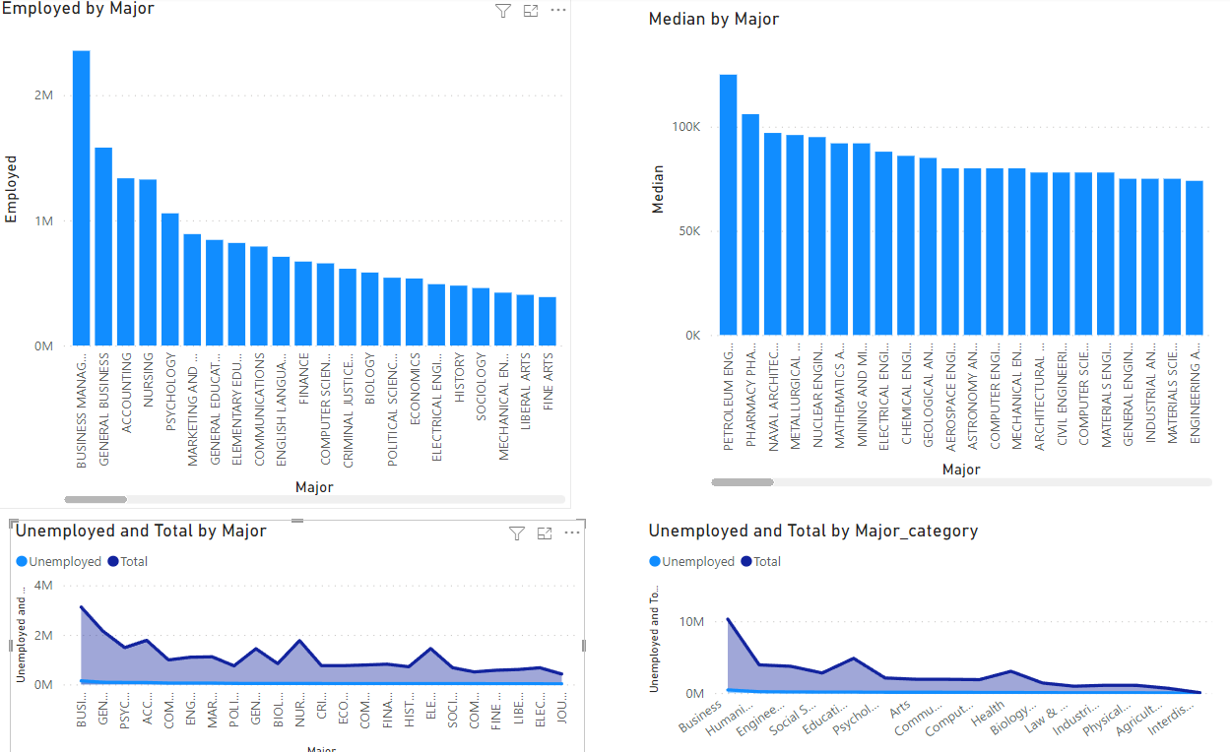

The above charts are reflective of employment levels by major according to the results of the 2012 survey. At a glance, it may seem that Business is both the best and the worst field to enter into as a young student. But these numbers can be deceiving if not considered in context. Business Management is by the largest major in the United States, the numbers it shows are somewhat inflated. When normalized, the numbers there are fairly similar to the average across all majors in the data set.

Additionally, above you will find a chart depicting median income by college major/industry. For practical purposes, there needs to be a weighting that takes place between the two which (to save space in this white paper) will be further explored and explained in a further presentation.

**Considerations**

Some assumptions are being made when looking at this data. The chief among them is that the numbers seen here continue to reflect the current climate in the United States. This project also assumes that a given student will have what could be referred to as a “Typical experience” regarding their choice of major. There are certainly going to be outliers which are not explored here, but it is important to point them out and acknowledge them.

The same problem could be considered a limitation of the project. There are likely some outlying data points that could potentially skew the numbers and this is of course possible that this data is no longer as accurate due to the time since it was compiled.

There are also parts of this data set that allow for the exploration of the representation of women in particular in these fields as well graduate students. For the purposes of this project in particular those numbers won’t be explored, but this data does exist and could be further explored in a future endeavor.

**Ethical Considerations**

On the face, I don’t see any major ethical considerations when thinking about the source for this data. The data itself is anonymous and in aggregate so there’s no way to expose the respondents to any real harm. The issue I can identify, however, is that if not properly represented, this data could be used counter to my stated purpose and ultimately misguide the students the project aims to help.

In pursuing this project, I will need to be careful about the manner in which I present the data so as not to accidentally or willfully misrepresent the reality of the situation in order to maintain the ethical “right” on this subject.